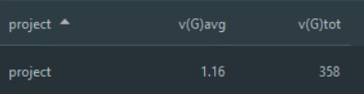**João Lima Metrics**

These metrics(Complexity Metrics -> Cyclomatic Complexity) are related to the number of linearly independent paths that the code can take. For exemple, if a method has an “if else” case, the code can take two paths(the true path, or the false Path), so the total cyclomatic complexity is two. So, when the method revolves in decision making code, the complexity will be higher.

I think the practical values shown are explained by the quantity of unnecessery if’s , loops… Even though there are many classes, so that would explain the total, number being this high. And the Average cyclomatic complexity doesn’t look too high.